- Creating a job with transformer stage

Estimated time
01:00

What this exercise is about
This exercise covers the process of creating a job with transformer stage, defining stage variable, constraint, function, and derivation in transformer stage

What you should be able to do
At the end of this exercise, you should be able to:
- Create a job with transformer stage
- Define stage variable constraint, function and derivation in transformer stage

Requirement
Before continuing with this exercise, the participant should have created database connection, job definition and parameter set explained in Lab Exercise 2.

Task: Create a parallel job with Transformer stage
- Open your project and click on Jobs tab after the project is opened.

- While in Jobs tab click on Create + button. A drop will appear, now click on Parallel job.
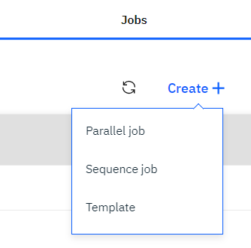
- Now you can see the below screen
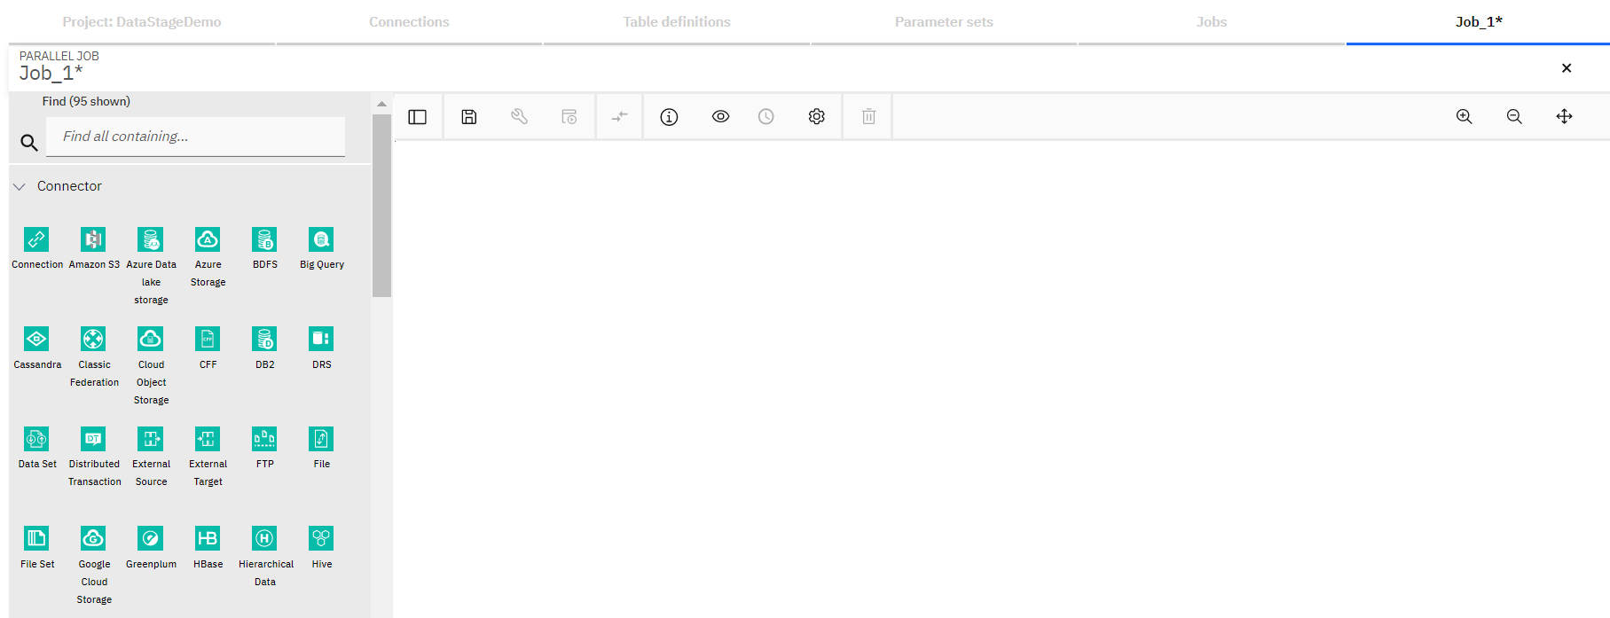
- Now type JDBC in the Find search box and you can see JDBC connector appears in the palette

- Drag the JDBC connector onto the canvas

- You can see Table definition asset browser window appears. Select BLUEDB\CP4D.BOOKS and click on Next.
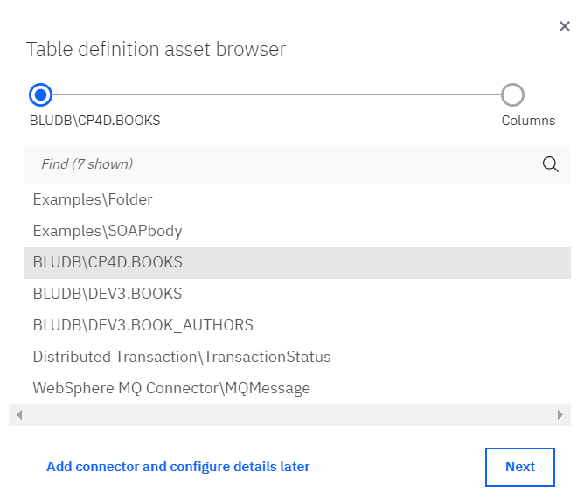
- In the next screen, by default, all columns are selected. Click on Add to job button.
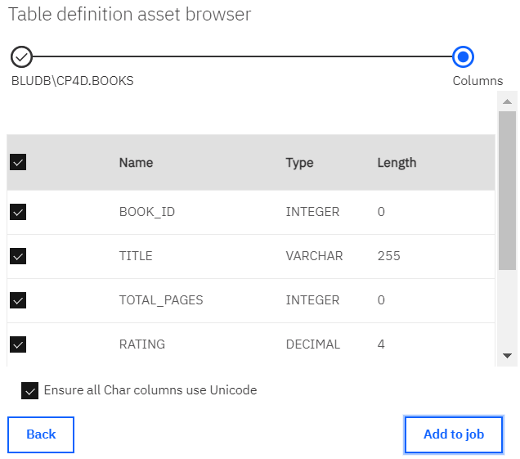
- Now search for transformer in the Find box and Transformer stage will appear. Drag the Transformer stage on to canvas and place it to the right of JDBC connector. Link the stages if not linked automatically.
- Search for Peek stage and add it on the canvas to the right of JDBC connector.
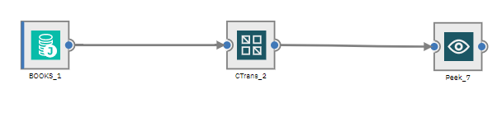
- Save the job by clicking on the save icon. Name it as Job_JDBC_Transformer.

- Click on the properties icon.
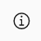
- In the Parameters tab of Job properties window, click on Add+ link.
- Click on Add+ again. In the Add Parameter window, select Parameter set in the Type dropdown and ps_JDBC_Conn in the Parameter name dropdown. Click on OK.
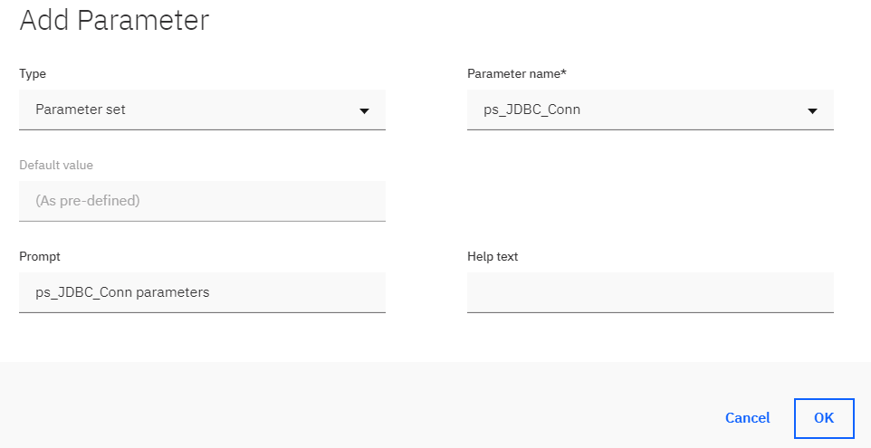
- Click on OK on the Job properties window.
- Double click on JDBC connector and the stage properties window will open.
- Change the name of the stage to JDBC_BOOKS_READ.

- In the URL textbox, click on the 3 horizontal blue dots
- A small window will appear next to the textbox. Click on #ps_JDBC_Conn.p_JDBC_URL#.
- Simillarly, select #ps_JDBC_Conn.p_Username# for User name text box and #ps_JDBC_Conn.p_Password# for Password text box.
- You can check if connector is connecting to the database successfully or not by clicking on the Test link.
- In the Table name text box, enter CP4D.BOOKS. Click on OK.
- Double click on the link from JDBC to Transformer stage and change its name to Link_ToXFM.
- Double click on the link from Transformer to Peek stage and change its name to Link_ToPeek
- Now, double click on Transformer stage and change the stage name to Trans_BOOKS.
- By default, Jump to dropdown would have Stage variable selected, if not select it.
- Click on Add + link
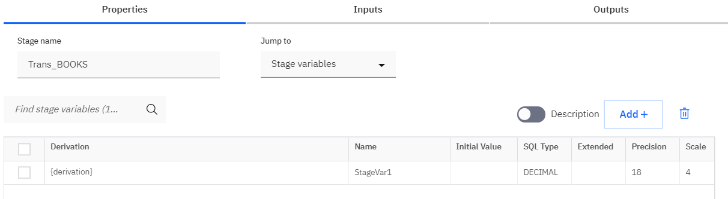
- Double click on the text DECIMAL under SQL Type column, a drop down will appear. Select VARCHAR. Double click on StageVar1 and change the name to sv_Suffix.
- Click on {derivation}, it’ll open Derivation Builder window.
- In the Derivation textarea, enter ' - BOOK'.
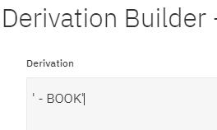
- Click on OK.
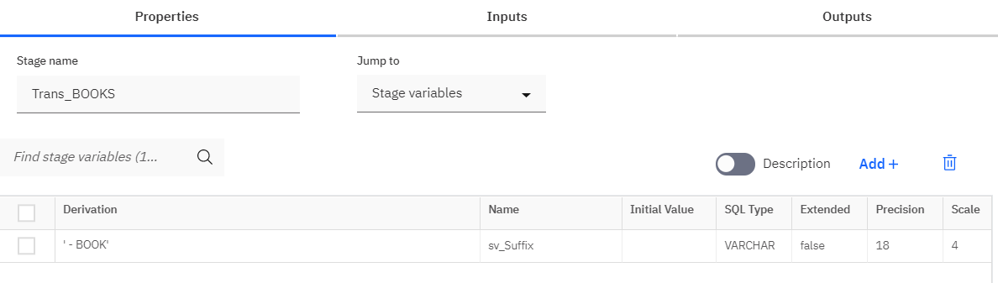

- Go to Outputs tab
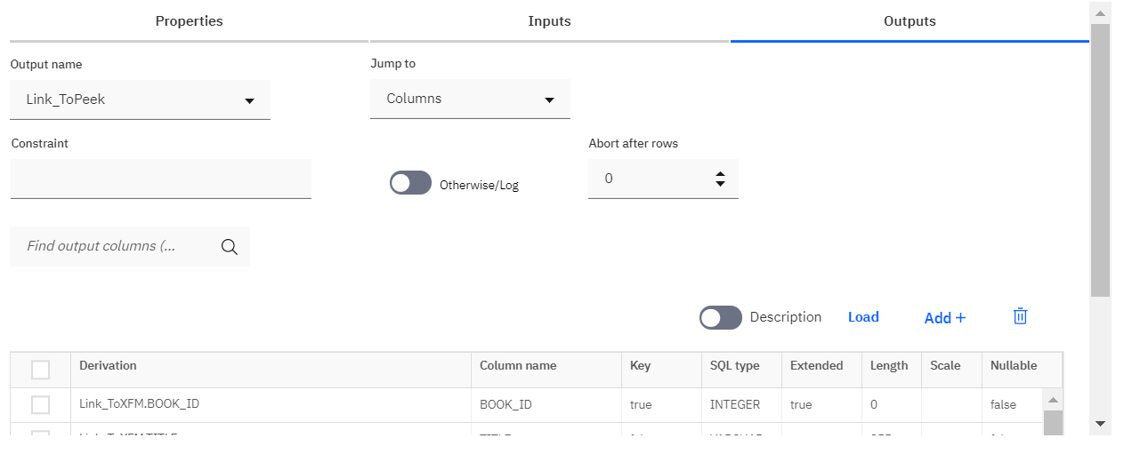
- Click on Constraint textbox and it will open Constraint Builder window.
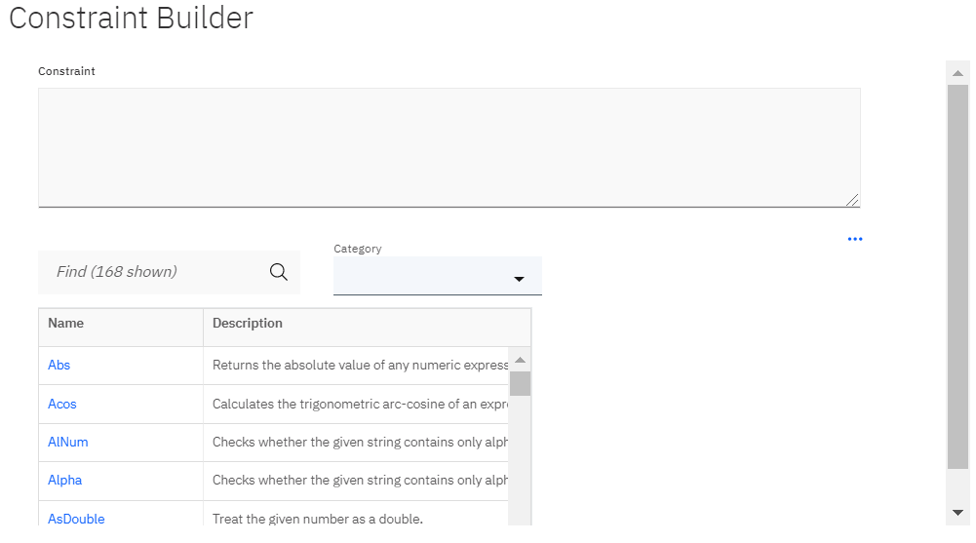
- Select Input Column from the Category dropdown and it’ll show all the input columns. Click on Link_ToXFM.RATING input column and it’ll appear in the constraint window. Then add > 4 text after it in the Constraint text area like in the screenshot below. Click on OK.
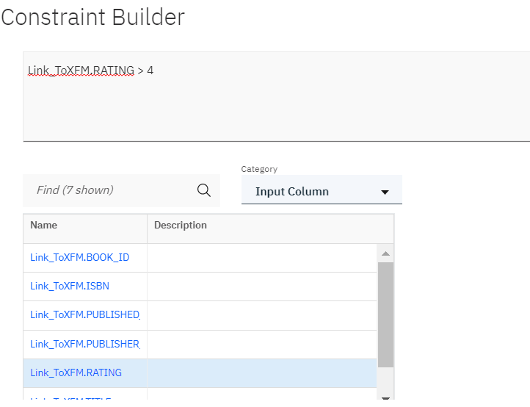

- Now, click on Link_ToXFM.TITLE in Derivation column
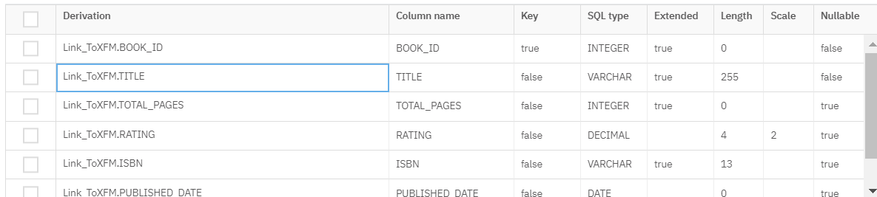

- Derivation builder window will open
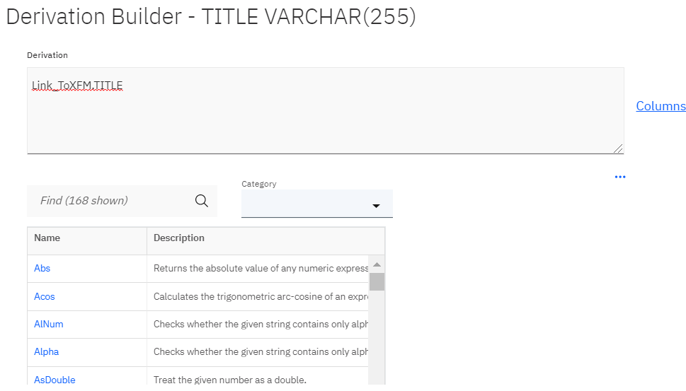

- Clear the Derivation textarea. In the Find serach box, type trim, as the Trim function appears click on it. Now Trim(%string%, [%stripchar_string%]) text would appear in the Derivation textarea.
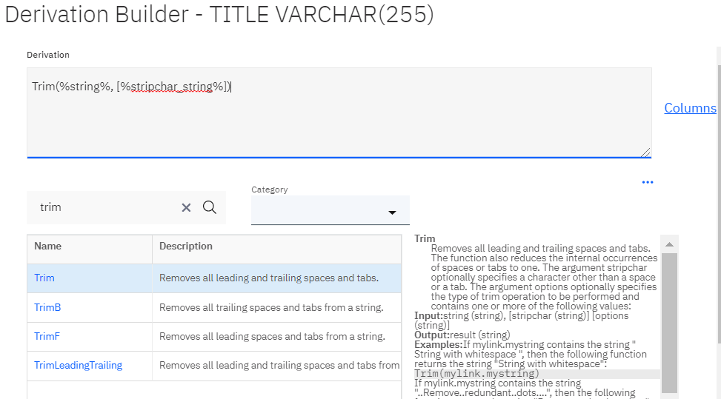

- Double click on %string% text and a dropdown will appear. Click on the drop down and select Link_ToXFM.TITLE.
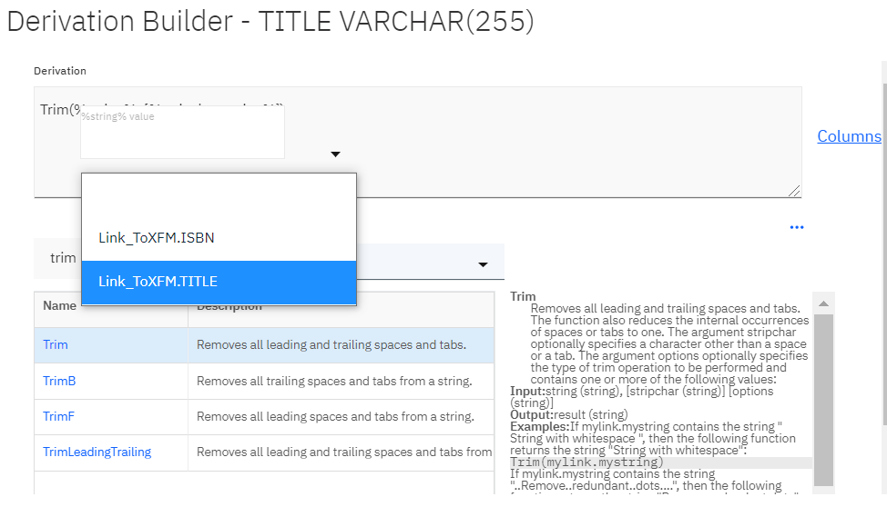
- Remove , [%stripchar_string%] , now the textarea should have Trim(Link_ToXFM.TITLE). After the text enter a space and then a colon (:) and a space again. Colon is concatenation operator.
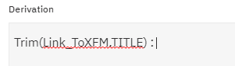
- Remove trim text from Find serach box. In the Category dropdown select Stage Variables and you’ll see sv_Suffix stage variable appears that we had created earlier. Click on that and it’ll appear in the Derivation textarea.
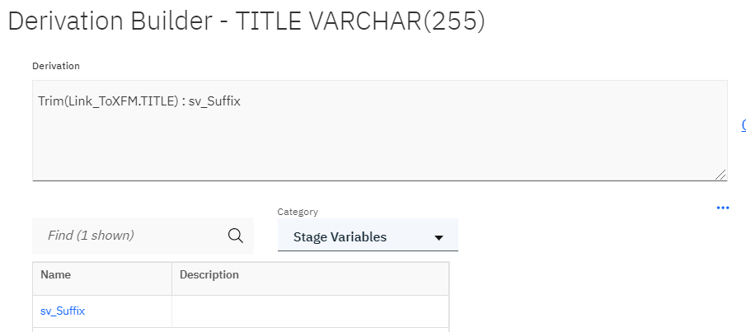

- Click on OK and the screen will look like below screenshot.
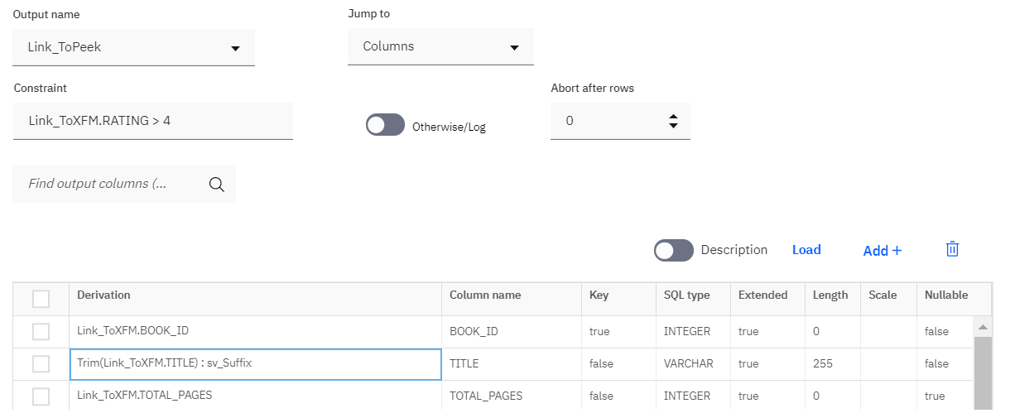
- Click on OK to return to the canvas.
- Double click on Peek stage and change its name to Peek_BOOKS.
- Save the job by clicking on the save icon.
- Compile and run the job.

